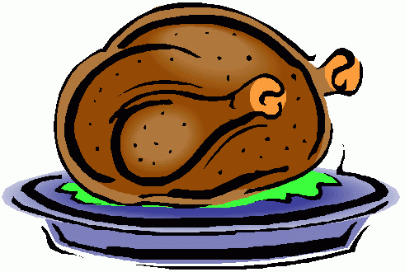***Washington Township “Gobble up Hunger Drive”***

*Sponsored by the Middle School Future Acts Program, the COW Project, Mother’s Cupboard, Students in Action, the WTEA, and The Rotary Club of Washington Township*

We have over 200 families to feed this holiday season!

* **Donations**: Donate a nonperishable item between **November 12th** and **November 23rd** to your child’s class. Suggested items include: turkey gravy, canned vegetables, instant or canned potatoes, cranberry sauce, stuffing, pasta, pasta sauce, rice, canned fruit, applesauce, peanut butter, and jelly.
* **After- School Pizza Party:** The classroom with the most canned goods from the winning school will receive a pizza party compliments of the COW Project.
* **Turkey Donations:** If you would like to donatea turkey to the cause,please contact Lindsay Radziak at [lradziak@wtps.org](mailto:lradziak@wtps.org) or call 856-582-3535 ext. 5513. All turkeys must be brought to your school’s main office on Tuesday November 24th. All donations will be accepted; however, we would appreciate a phone call or email to Mrs. Radziak to get an approximate number of turkeys beforehand.
* **Deliveries:** If you would like to volunteer to deliver a turkey, please contact Maddy LaVoe at [mlavoe@wtps.org](mailto:mlavoe@wtps.org) or call 856-582-5353 ext.5709. **E-mail is preferred!**

***Washington Township is well known for its dedication and commitment to community service. As you can see, this is an incredibly ambitious project that requires a team effort. Please take some time to explain the importance of giving and caring to your child and join the number one team in New Jersey, the Washington Township Community, in making this a very meaningful Thanksgiving.***

***Thank you in advance for your anticipated participation!***

**If your family is in need of a food basket, please contact**

**Maddy La Voe at** [**Mlavoe@wtps.org**](mailto:Mlavoe@wtps.org)